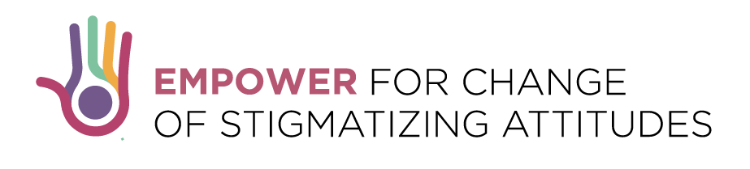

COMPETITION FOR YOUNG JOURNALISTS
Deadline: 15 of October, 2017 (23:59h CET)

Europe is facing with increasing number of migrants and refugees while the risk of radicalization, which mostly affects youth, is growing. Number of young, socially excluded, people are being drawn into extremist movements in their search for identity and a place in society.

Having in mind the important role media and journalists play in modern society we call young journalist to apply for the award on the topics of migrants, integration, radicalization, or youth democratic values. The award of 2000EUR per country is available for young journalists working in Belgium, Bosnia and Hercegovina, Germany, Hungary, Italy, Macedonia, Montenegro, and Serbia. With support of CDT and it local partners the awarded journalist will have an opportunity to further develop their investigative journalistic skills and upgrade their story.

Who can apply?
Young journalists from 18 to 30 (including those born in1987) employed in media outlets in Belgium, Bosnia and Hercegovina, Germany, Hungary, Italy, Macedonia, Montenegro, and Serbia who are already reported on one of the above topics and are eager to further explore the issue.

How to apply?
Interested candidate should send:
- CV (personal and professional data sheet, according to Europass standards or similar),
- up to three samples of journalistic work;
- contact information of media they are employed in;
- brief summary (up to 500 words) how they can upgrade their past works related to topics: reasons why you believe your story is relevant, what research they could do to explore the issue further, with whom they would conduct interview, and where they will publish their work.
- The applications should be submitted in English while the samples of past work can be submitted in local language.

Interested candidates should apply via e-mail: cdtmn@t-com.me . They should clearly indicate in the subject: Application for Journalist Competition. Applications for the award should be submitted no later than 15 of October, 2017 (23:59h CET)
For online work samples, insert hyperlinks in a PDF document, or print out online articles in a PDF file. Hyperlinks need to be accessible until 16 of October 2017.
For audio/video material, please upload the files making use of file sharing services (e.g. WeTransfer or Dropbox).
For all questions please contact Andjelija Lučić, Project Coordinator at: andjelija@cdtmn.org
Selection process
In each eligible country Commission composed of three representatives of CSOs with relevant experience and knowledge on the topics and media will select the best candidate. The country Commissions reserve right to select more than one candidate. The applications will be assessed based on the relevance of the topic for each country, competences and past experience of journalists, and potential outreach.

After the selection process in close cooperation with CDT team and local partners’ journalist will have a month to further develop their investigative journalistic skills and upgrade their story.

The Commission in each country reserves a right to select more than one candidate (up to four) and accordingly split the award budget.

This activity is a part of the project “Empower for Change of Stigmatizing Attitudes” co-financed by the Erasmus+ Programme of the European Union which Center for Democratic Transition from Montenegro implements with JumpIn – Italy, Proni Center for Youth Development – Bosnia and Hercegovina, Central European Heritage – Hungary, Asylum Protection Center – Serbia, EUFRAK-EuroConsults – Germany, Institute for Democracy “Societas Civilis“ – Macedonia and European Projects Association – Belgium.

