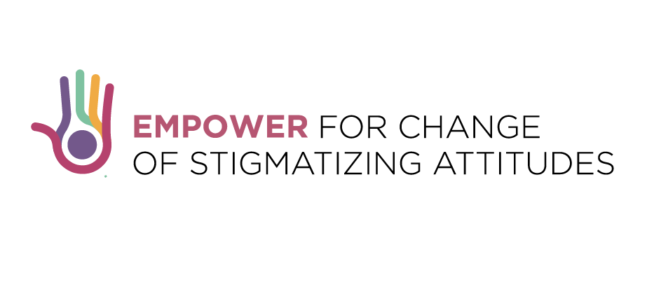

**EXTENDED COMPETITION FOR YOUNG JOURNALISTS**

**IN BOSNIA AND HERZEGOVINA**

**Deadline: 17 of November, 2017 (23:59h CET)**

*Europe is facing with increasing number of migrants and refugees while the risk of radicalization, which mostly affects youth, is growing. Number of young, socially excluded, people are being drawn into extremist movements in their search for identity and a place in society.*

*Having in mind the important role media and journalists play in modern society we call young journalist from* ***Bosnia and Herzegovina*** *to apply for journalists’ award on the topics of* ***migrants, integration, radicalization, or youth democratic values.*** The total award fund is 2000EUR. With support of CDT and its local partners the awarded journalist will have the opportunity to further develop their investigative journalistic skills and upgrade their story.

***Who can apply?***

Young journalists from 18 to 30 (including those born in 1987) employed in media outlets Bosnia and Hercegovina who already reported on one of the above topics and are eager to further explore the issues.

**How to apply?**

Interested candidate should send:

* CV (personal and professional data sheet, according to Europass standards or similar),
* up to three samples of journalistic work;
* contact information of media they are employed in;
* brief summary (up to 500 words) on how they can upgrade their past work related to topics (please try to provide the following info: reasons why you believe your story is relevant, what research you could carry out to explore the issue further, who you will interview, and where you will publish story);
* The applications should be submitted in English while the samples of past work can be submitted in local language.

Interested candidates should apply via e-mail**:** [**cdtmn@t-com.me**](mailto:cdtmn@t-com.me)**.** Applications should be Cc-ed to [**buliclola@yahoo.com**](mailto:buliclola@yahoo.com)

They should clearly indicate in the **e-mail subject: *Application for Journalist Competition*.** Applications for the award should be submitted **no later than 17 of November, 2017 (23:59h CET).**

For online work samples, insert hyperlinks in a PDF document, or print out online articles in a PDF file. **Hyperlinks need to be accessible until 19 of November 2017.** For audio/video material, please upload the files making use of file sharing services (e.g. WeTransfer or Dropbox).

For all questions please contact Andjelija Lučić, CDT Project Coordinator at: [andjelija@cdtmn.org](mailto:andjelija@cdtmn.org) or Slavka Bulić Zovko “PRONI” Centre for Youth Development at: [buliclola@yahoo.com](mailto:buliclola@yahoo.com)

**Selection process**

Commission composed of three representatives of CSOs with relevant experience and knowledge on the topics and media will select the best candidate. The Commission reserve right to select more than one candidate. The applications will be assessed based on the relevance of the topic the country, competences and past experience of journalists, and potential outreach.

After the selection process in close cooperation with CDT team and local partners’ journalist will have a month to further develop their investigative journalistic skills and upgrade their story.

The Commission in each country reserves a right to select more than one candidate (up to four) and accordingly split the award budget.

**Note: Additional clarifications regarding the call will be published weekly on CDT portal.**

*This activity is a part of the project “Empower for Change of Stigmatizing Attitudes” co-financed by the Erasmus+ Programme of the European Union which Center for Democratic Transition from Montenegro implements with JumpIn – Italy, Proni Center for Youth Development – Bosnia and Hercegovina, Central European Heritage – Hungary, Asylum Protection Center – Serbia, EUFRAK-EuroConsults – Germany, Institute for Democracy “Societas Civilis“– Macedonia and European Projects Association – Belgium.*



**Additional clarifications (published on October 3, 2017)**

* Media outlets include newspapers, magazines, radio, television, and the Internet;
* An applicant in order to be eligible should be employed in media either as a full, part time, or casual journalist, correspondent/columnist, apprentice or trainee…;
* Teams of journalist are eligible to apply.